Azure paas database

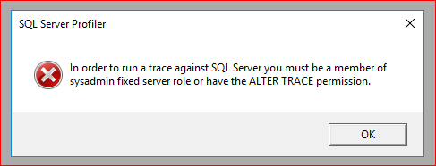

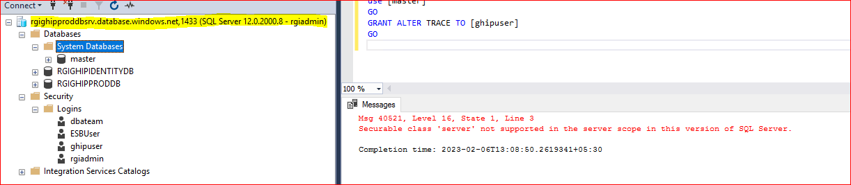

use [master]

GO

GRANT ALTER TRACE TO [ghipuser]

GO

Securable class 'server' not supported in the server scope in this version of SQL Server.